Жар-птица знаний – 2018
Международный некоммерческий конкурс
просветительно-творческих проектов учащихся

проект « Семейный обед»

Предметная область: английский язык
Возрастная категория: 3 класс

Участник (автор): Николаева Е. А.
Руководитель (педагог): Ефремова А.С.

г. Балашиха
2018
Presentation
The aim of the work is to cook a family dinner.
The objectives:
- to cook various dishes
- to invent new recipes
- to find out the opinions of relatives concerning the meals prepared
- to gather our friendly family not only in the dining room but in the kitchen as well
The problems:
- to make tasty dishes
- to present the dishes beautifully
- to present our ideas in English
There is a tradition in our country to gather together for family dinners. We also look forward to seeing the guests in our house – our friends and relatives. According to Russian traditions we can` t imagine any party without a festivale table, that` s why we are keen on cooking.
All our relatives are very creative people. They don` t enjoy eating tasteless and unhealthy fast food. We prefer cooking at home trying to choose fresh food and create new dishes. After watching different TV shows or surfing the Net we put down the recipes, discuss them but while cooking always add and change something according to our tastes.
The adults in the family love meat but the children prefer vegetables and soup. Everyone is mad about seafood so we cook soup, meat and fish regularly.
We are eager to share our recipes and see if you like the dishes or not. All the family support us in our desire to cook something special. Of course, we don` t want our dishes to be too expensive and not fat, either. We are for healthy and cheap food. We don` t want cooking to be time consuming. We want it to be pleasant and enjoyable.
We decided to present our ideas in English because we travel a lot, know much about food and meals and try to order them in English in any country. Moreover, we have friends who are going to open a restaurant and we want to help them to attract the customers both Russian and foreigners, that` s why we should be able to describe the dish in English.
Follow us! Enjoy cooking!
Bon appetite!

Spaghetti with mussels
Ingredients:
- Spaghetti;
- Mussels;
- Olive oil;
- Salt;
- Cream;
- Ketchup;
- A tomato;
- Garlic.
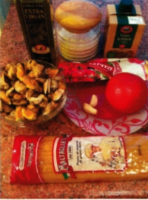
Recipe:
- Boil spaghetti for 3-5 min.
- Fry the mussels for 5-7 min.

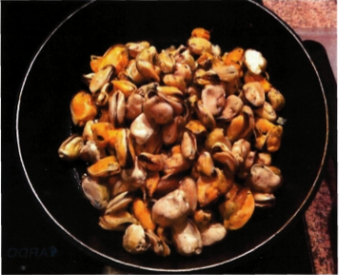

- Add some ketchup, a tomato and the garlic.

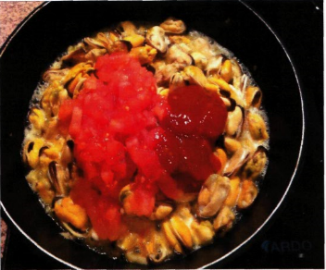

- Add some cream.

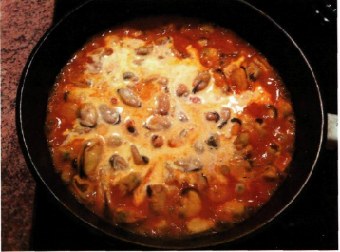

- Mix the spaghetti with the mussels and stir while cooking.
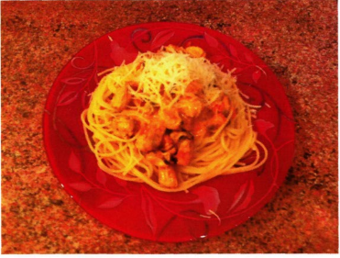

- Put onto a plate.

Enjoy!

Quality assessment:
my family and I 5- (it lacks salt)
relatives: 5

Eggs stuffed with yolk, cheese with spices

Ingredients:

- 5 boiled eggs;
- 1 carrot;
- Butter;
- Cheese;
- Paprika;
- Salt
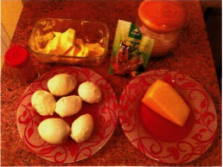

Recipe:
- Cut the eggs into two parts

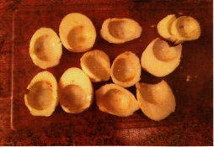

- Mix some pepper, yolks, butter and cheese to make the stuffing;
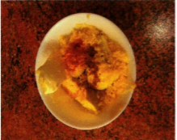
- Fill the halves eggs with the stuffing;
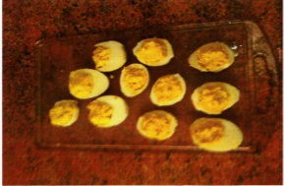

Quality assessment:
my family and I: 4 (not very beautiful)
relatives: 5

Pumpkin soup with ginger

Ingredients:

- A piece of pumpkin;
- A carrot;
- 2 onions;
- A piece of ginger root;
- Water – 500 ml;
- Garlic - to your taste;
- Olive oil – 2 tablespoons;
- A cube of chicken broth

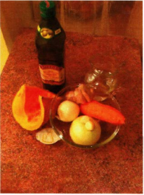
Recipe:

- Chop the pumpkin, the carrots, the onions and put them into a pan having added some olive oil;
- Pour the water, add some salt, a cube of chicken broth and boil for 20 minutes.
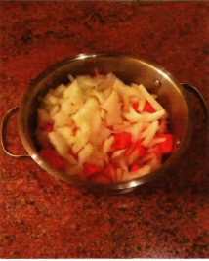
Enjoy!
Quality assessment: my family and I: 5 + relatives:5 +
Salad with pear and avocado

Ingredients:

- A pear;
- An avocado;
- A lemon;
- Half a pepper;
- Mustard;
- Salt;
- Olive oil;
- Honey

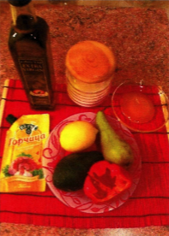
Recipe:

- Chop an avocado, a pear and a red pepper;
- Add a little lemon juice and honey;
- Put some olive oil;
- Mix


Quality assessment:
my family and I 5
relatives 5 +
