A lawn on a football pitch

Author: Korotkin Georgiy Vyacheslavovich
Teacher: Bobrova Tatyana Alexandrovna
Class: 6 "V"
School: Moscow, SBEI school N* 648 named after the hero of Russian Federation A. G. Carlov

Who plays football, knows, that on a natural grass it is more convenient to play than on others coatings.
There is an old English anecdote: a good lawn is the one .hat has been taken care of for 300 years. But in the modern football it is made much faster.
1 A structure
Everybody knows, that a football pitch is rectangular. But it is not flat, a central round on 25 - 28cm higher that edges. It is called "a cover".
Now a football pitch is an agro technical installation and has some layers. The lowest is a drainage system, These are ducts, in which water flows down and, then, is deleted beyond the edges of a pitch. Above it is a layer of ducts of heating. A heating may be by electricity, but by water it is cheaper. Snow melts on a warm pitch (10 - 15*C), and water flows down in drainage ducts.
The next layer is, 10cm high and consists of large and then small sand and crushed stone. Above it there are 10cm of turf, a mixture of sand and humus. And, in the end, grass. This construction may reach 1m thick.
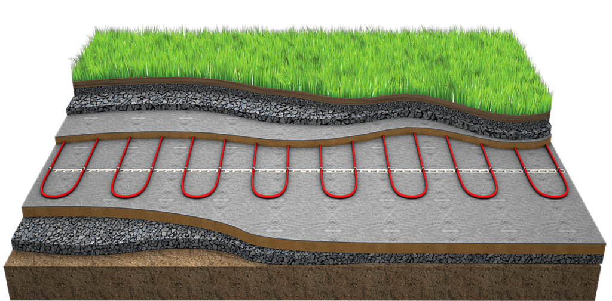

2 What kind of grass is planted
For a seeding you choose perennial herbs, which grow fast and little trampling. And goalmouth is sown in 2 times denser that the rest of the pitch. Mixtures of herbs include: the ryegrass pasture, the oatmeal red, the oatmeal meadow, the bent grass, the blue grass meadow. A specialist in football pitches Givi Georgievich Abramishvili even brought out the new kind of lawn grass, it is the mixture of the bent grass and the bluegrass creeping, and called it "Spartak".

2
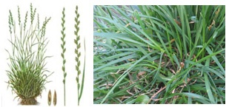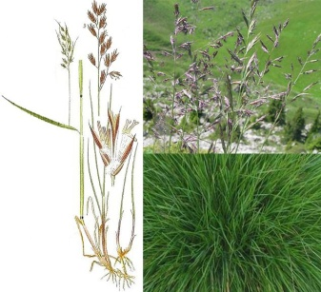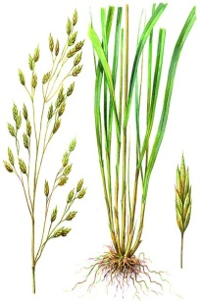
the reygrass the oatmeal red the oatmeal meadow
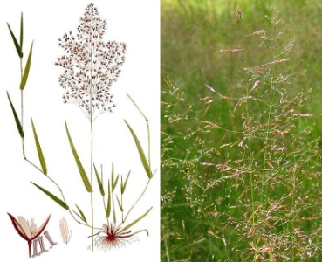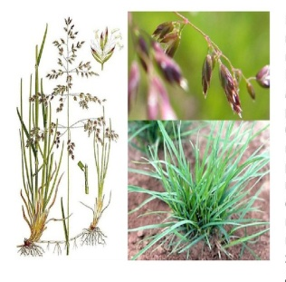
the bent grass the bluegrass meaddow
Grass is not just sown on the pitch either. It grow is on special farms, is cut into strips and folded. Those rolls are rolled out in the pitch. As needed, after trampling, in some places a grass is sown. So that a lawn wears less, natural grass is sown with 20cm synthetic bushes. After this operation the pitch becomes more reliable. After marking the pitch is ready for a game.
3 Care
As a complex ecosystem a football pitch requires a constant care. Water a lawn, pierce the ground with special rods for air access, fertilize, fight the weeds, chase away birds. 2 - 3 times a week mow the grass with special lawn mowers. Height of a lawn is no more than 5cm. After each game a pitch, pitted with boots of football players, must be restored. Trampled places, especially goalie and penalty areas are sown again.

Grass on a football pitch requires a constant care of professional agronomists. So it hurts to watch how matches spoil a lawn. For football players it is comfortable to run on an ideal pitch, there are fewer injuries, a ball rolls and bounces in the right way. And each fan of football enjoys watching the emerald pitch.
Materials used:
1 spokoino.ru 5 bolshoyvopros.ru
2 kosilki.ru 6 touch.otvet.mail.ru
3 gazon52.ru 7 the-village.ru
4 спорт-инжиниринг34.рф 8 sport-express.ru
3

