I и II типы слога
Step 1
 | I тип  (на конце гл) | II тип  (на конце согл)
Aa | ЭЙ | Э
Ee | И | Э
Oo | ОУ | О
Ii, Yy | АЙ | И
Uu | Ю  (редко У) | А  (редко У)

Aa – rate (рэйт) I тип слога
rat (рэт) II тип слога
Ee – pete (пит) I тип слога
pet (пэт) II тип слога
Оо – note (ноут) I тип слога
not (нот) II тип слога
Ii, Yy – site (сайт) I тип слога
sit (сит) II тип слога
Uu – cute (кют) I тип слога
cut ( кат) II тип слога

Закрепление I и II типов слогов
Прочитай слова. Определите тип слога. Распредели их на две группы – I и II типы в таблице и прочитайте:
Oo
[оу] |  | [o]

rose, vote, lot, code, hello, top, sofa, dote, dot, dose, dog, smoke, smog

Aa
[эй] | [э]

name, hate, hat., made, make, babe, bad, bat, date, late, man

Ii,Yy
[ай] | [и]

film. milk, bye, my, in, it, hi,

type, line, bit, I, like, pipe

Ee
[и] | [э]
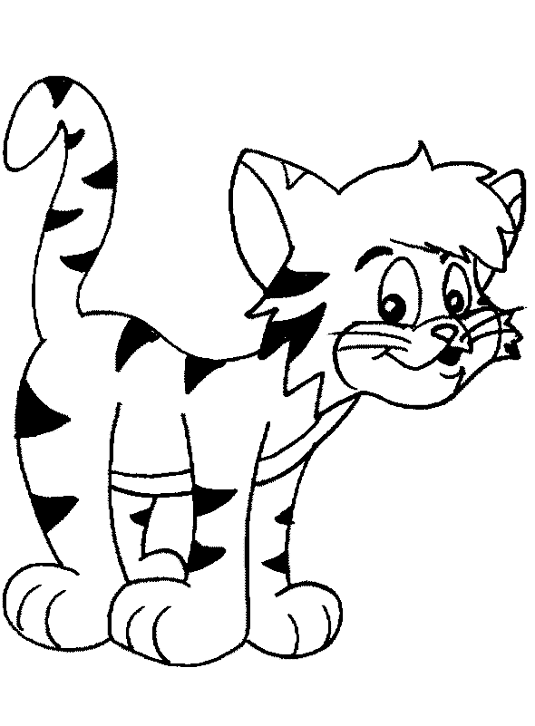
Pete, ten, test, let, me, he, end,

yes, metе, met, pet, fete, set

Uu
[ю] | [а]

but, music, fun, cube, jump, up, pupil, bug, tube, bubble

Aa
Ex. 1. Чтение буквы Aa в закрытом слоге:
am | has | bad | clap | stand
as | sad | hat | lamp | hand
and | dad | map | stamp | land
ant | can | cat | tram | plan
Ex. 2. Чтение буквы Aa в открытом слоге:
age face name date take
page place came gate cage
space game late make bake

pan pane mat mate
Sam same glad glade
man mane hat hate 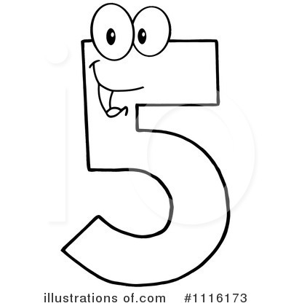
tram tame fan face
can cane mad . made
Ee
Exercise 1. Чтение буквы Ee в закрытом слоге:
bell | let | Rex | pen | get
tell | pet | flex | cent | nest
spell | bed | text | end | best
smell | red | next | desk | west

Exercise 2. Чтение буквы Ee в открытом слоге:
me we eve Steve
Pete Bede he be
Ii
Exercise 1. Чтение буквы Ii в закрытом слоге:
in | pin | fix | trip | list | did | skip
it | lit | mix | print | brisk | dig | win
is | his | six | film | risk | slim | wind
i11 | tiII | still | silk | disk | bridge | twin
its | sit | spill | milk | clip | Jim | twist
Exercise 2. Чтение буквы Ii в открытом слоге:
I | five | like |  | fine | wife | size
hi | nine | tidy |  | pipe | mile | mice
lie | nice | dive |  | ride | stripe | price
tie | bike | life |  | drive | rise | kite
pie | time | hide |  | side | ice | mile

rid ride
grid bride
milk mine
win wine
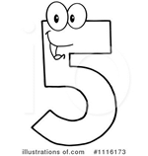

Oo
Exercise 1. Чтение буквы Oo в закрытом слоге:
on | dog | · hot | box | doll
of off god job | fog frog log jog | dot lot hot got | fox cross lost pond | drop hop stop spot

Exercise 2. Чтение буквы Oo в открытом слоге:
go | nose | rose | note | hope
so no | close home | open joke | tone stone | rope globe

not | note | cross | - rose
cod | code | hop | hope
 | Uu
Exercise 1. Чтение буквы Uu в закрытом слоге:
use | mute | due | pupil
muse | tube | cute | student
fuse | huge | mule | cucumber

Exercise 2. Чтение буквы Uu в открытом слоге:
true  ,blue | rude flute | June juice
rule | Bruce | prune

cub cube
tub tube
us use
cut cute

Yy

Exercise 1. Чтение буквы Yy в закрытом слоге:

gyp system
gym symbol
lyric

Exercise 2. Чтение буквы Yy в открытом слоге:
by try type

my | dry | cycle | July
fly | cry | bye

Control tasks
Exercise 1. Aa
1) mat, snat, cat, sat, hat, ham, pat, fat
2) name , game, lake, plate, take, tale, tame, hate, hake
3) name, cat, lake, ban, fame, map, make, lamp
Exercise 2.
a black cat
a bad snake
a fat rat
a black rat and a fat cat
a cake and a plate
a black bat hat
Exercise 3.
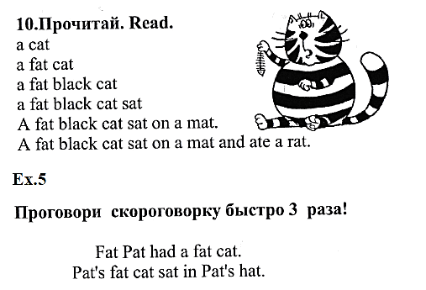

Exercise 1. Ee
1) ten, net, pen, pet, set, sent, sell
2) me, be, he, feme, mete, bede, dene
3) end, me, men, be, bent, mete, den, bedе
Exercise 2.
green pen
red desk
Pete and a bee
Ted and his pet
а black desk
a big red hen

Exercise 1. Ii, Yy
1) Bit, bin, kid, mist, lick, fix, mix
2) Pie, five, time, tie, die, lie, bike, type
3) six, ice, kid, pie, kiss, five, nib, tie, sic
Exercise 2.
a little kite
a little pig
little mice
a nice bike
a nice ca a nice pet
nice mice

Exercise 3.
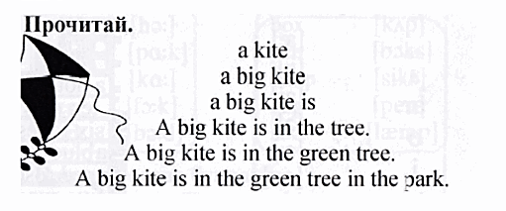
Exercise 1. Uu
1) Up, cup, nut, sun, pun, pup, punt, cut, sup
2) Tune, due, duke, dune, puke, dupe, puce, tube
3) Up, tule, cup, puce, nut, dupe, sun, puke, pun, dune
Exercise 2.
a sunny smile
a big bus and a little cup
A big funny puppy
Exercise 1. Oo
1) got, not, dot, spot, cot, pot, lot
2) bone, rope, note, pose, dose, hose, stone, nose
3) poke, got, note, not, hope, hop, coke, cot, spoke, spot
Exercise 2.
go home a big box
a big dog a box and a dog
a big doll

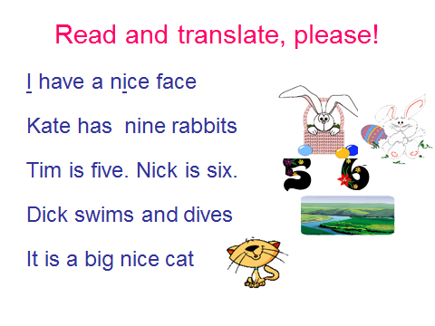

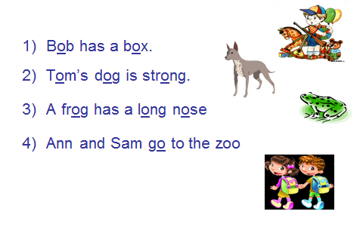

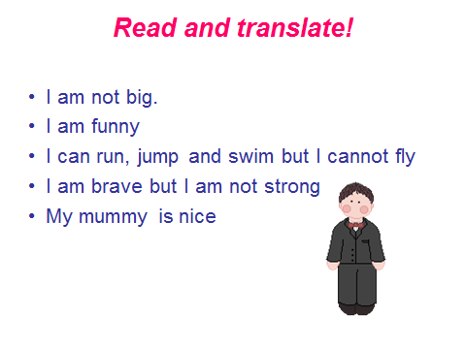
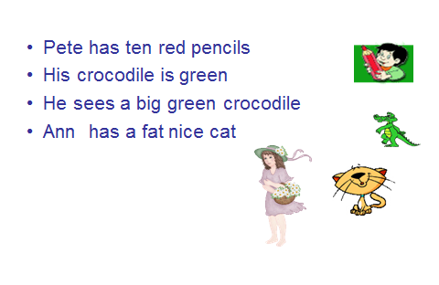
Тексты для чтения
Text 1
See a red beet. Take a pen. Take a hen. Keep a green pen. See a black desk. Take a pen, Pete. His pen is bad. His desk is big. Ted, see a big bee. Tim has seven red pens. Ann has a grey cat. Ten rabbits can skip. Ann’s pen is red.
Text 2
His hens can swim and sing. A black pig isn’t fat. Can a grey rat sit? Is his lamp red? I like my bike. I like my cat. I like my big fat cat. I like my nice little pink pig. I am fine. I like my little nice mice. I like my nice pink kite. I like it.
Text 3
Tim sings. Tim is six. His pig is big. Six pigs skip. Jim swims. Is Jim slim? Is his pig big? His pig isn’t big. Jim isn’t slim. Tim isn’t six. I like cats and dogs. Bob likes funny dogs. Nick likes rabbits and foxes. Ann likes bees and ducks.
Text 4
She has nice ducks. Nick has nine rabbits. A crocodile likes red pens. It’s time to swim and to skip. I like crocodiles. Crocodile Gena is strong. It can swim, run, and jump. I can ride a crocodile. Crocodiles like it.
Text 5
Take a cat. Take a plate. Take a black rat and a fat cat. Take a map. Take a cake, Kate. Jane, take a parrot and a carrot. Take a fat cat and a black hat, Sam.
Text 6
Dogs can jump. A cat can skip. But it can’t swim. Big pigs can’t run. Bob must sing. But he must not run. Tom’s cat is funny. A duck can’t sing. A frog is ugly. A big grey duck can swim. A cat can jump.
Text 7
Go home. A big dog has a big clock. A small frog has a big box. Open a box. A frog opens a small box. I have at a doll at home. He is not big. He has a funny face. He has a nice hat.

Step 2

III и IV типы слогов
 | III тип- гл+г | IV тип-гл.+re
Aa | ar А | are ЭЭ
Ee | er Ё | ere ИЭ
Oo | or О | ore О
Ii, Yy | ir,yr Ё | i,yre АЙЭ
Uu | ur Ё | ure ЮЭ

Aa –car (ка)
care (кээ) IV тип слога
Ee – tern (тён) III тип слога
pere (пиэ) IV тип слога
Оо – short (щот) III тип слога
sore (со) IV тип слога
Ii, Yy – skirt (скёт) III тип слога
fire (файэ) IV тип слога
Uu – curl (кёл) III тип слога cure ( кюэ) IV тип слога
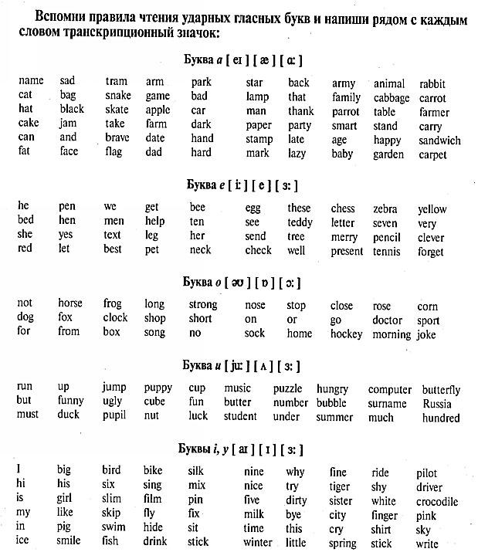

Control task
III тип слога
1) stern , far, curt, hard, hart, car, card, cart, fork, cork, work, sort, term, first, Byrd, furs, curl, her,
2) curb, turn, girl, sir, burn, turn, word, born, torn, bird, form, serf, herb, arm, start, serve, firm, verb, hurt
IV тип слога
1) fare , here, pure, rare cure, dure, mare, fire, bare, mire, stare tire, sere, mere, store, core
2) more, care, mere, cure, store, pure, fare, lyre, hire, sere, fire, bore, tyre, dare,
more, here

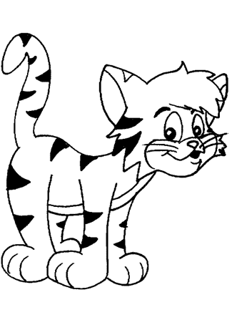

Контроль чтения 4-х типов слога

Control test
Распредели слова по 4 типам слогов и прочитай:

Park, sort, dark, lake, like, byre, sit, tip, cure, sore, fire, type mine, gave, nose, bird, curl, gist, gym, dirty, form, horn, herb, darling, pile, face, tide, game, nice, page, type, code, size, wise, pose, dare, hire, serial, care, pure, first, myrtle, fix, cat, bag, bit, big, stamp, pencil, myth, stuff, her, fur, large, garden.

I | II | III | IV

