Step 1 English letter combinations
Согласные буквосочетания
№ | Группа | Сочетания | Звуки | Примеры
1 | Обычные | ck | [k] к | clock, stick, luck
 |  | qu | [kw] кв | queen, quick, question
 |  | (d)g | [dʒ] дж | bridge, edge, lodge
2 | Шипящие | sh | [∫] щ | ship, smash, show, astonish
 |  | ch, tch | [t∫] ч | chat, fetch, such
3 | Межзубные | th | [Ө] ф | thank, thin, bath, myth, three
 |  | th | [ð] в | mother, bathe, clothes, this, the, than
4 | Греческое | ph | [f] ф | photo , telephone , triumph
5 | Носовые | -ng | [ŋ] н | sing, coming, wing
 |  | nk, n+[k] | [ŋk] н | think, uncle
6 | Немые | kn- | [n] н | knight, know, knee
 |  | wr | [r] р | write, wrist, wrong
 |  | wh | [w] в | when , why , whirl, whale

№ | Группа | Сочетания | Звуки | Примеры
1 | Обычные | ck | [k] к | clock, stick, luck
 |  | qu | [kw] кв | queen, quick, question
 |  | (d)g | [dʒ] дж | bridge, edge, lodge
2 | Шипящие | sh | [∫] щ | ship, smash, show, astonish
 |  | ch, tch | [t∫] ч | chat, fetch, such
3 | Межзубные | th | [Ө] ф | thank, thin, bath, myth, three
 |  | th | [ð] в | mother, bathe, clothes, this, the, than
4 | Греческое | ph | [f] ф | photo , telephone , triumph
5 | Носовые | -ng | [ŋ] н | sing, coming, wing
 |  | nk, n+[k] | [ŋk] н | think, uncle
6 | Немые | kn- | [n] н | knight, know, knee
 |  | wr | [r] р | write, wrist, wrong
 |  | wh | [w] в | when , why , whirl, whale

Гласные буквосочетания
Английские буквосочетания
- i_gh [ ай ] right, flight, bright, might, fight  - wa [ во ] wasp, want, wash, wand, water  - o_m, n, v, th [ а ] son, mother, other, London  - ow [ ау ] town, brown, crown, clown, gown  - ow на конце [ оу ] window, grow, low, show, borrow  - wh + o [ hu ] who, whom, whose  - oy [ ой ] boy, soy, toy, joy, coy  - ay [ эй ] day, way, say, play, may, lay, bay  - ture [ че ] culture, lecture, future, nature, sculpture, creature  - i_nd, ld [ ай ] kind, mind, find, mild, wild  - air [ ээ ] fair, air, hair, chair, pair  - a _ 11 [ ол ] small, call, stall, ball, all, tall, wall  13. ou [ ау ] house, mouse, cloud, count  14. u _ 11 [ у ] full, pull, bull, push, bush  15. a_n+согл. [a] answer, branch, dance, chance, -glance | 17. oo _[ у ] book, look ,boot, spoon, good, moon, too  16. o_ld [ оулд ] cold, gold, told, hold, sold  17. ee, ea [ и ] see, weak ,beach ,tree, lead, need  18. our [ о ] four, your, course  19. alk [ о ] walk, talk, chalk  20. au [ о ] author, pause, Paul, autumn, August  21. ea _d [ e ] bread, head, ready, dead ( искл. read, lead)  22. ou, au _ gh [ о ] brought, fought, thought, bought, daughter  23. a _ ss, st, sk [ a ] class, mask, last, grass, fast, master, ask,task, past  24. ey на конце [ эй ], ey [ и ] they, grey, hey, obey, money, honey,Betsey  25. ew [ ью ] few, new, drew, grew, blew, knew
Английские буквосочетания
- i_gh [ ай ] right, flight, bright, might, fight  - wa [ во ] wasp, want, wash, wand, water  - o_m, n, v, th [ а ] son, mother, other, London  - ow [ ау ] town, brown, crown, clown, gown  - ow на конце [ оу ] window, grow, low, show, borrow  - wh + o [ hu ] who, whom, whose  - oy [ ой ] boy, soy, toy, joy, coy  - ay [ эй ] day, way, say, play, may, lay, bay  - ture [ че ] culture, lecture, future, nature, sculpture, creature  - i_nd, ld [ ай ] kind, mind, find, mild, wild  - air [ ээ ] fair, air, hair, chair, pair  - a _ 11 [ ол ] small, call, stall, ball, all, tall, wall  13. ou [ ау ] house, mouse, cloud, count  14. u _ 11 [ у ] full, pull, bull, push, bush  15. a_n+согл. [a] answer, branch, dance, chance, -glance | 17. oo _[ у ] book, look ,boot, spoon, good, moon, too  16. o_ld [ оулд ] cold, gold, told, hold, sold  17. ee, ea [ и ] see, weak ,beach ,tree, lead, need  18. our [ о ] four, your, course  19. alk [ о ] walk, talk, chalk  20. au [ о ] author, pause, Paul, autumn, August  21. ea _d [ e ] bread, head, ready, dead ( искл. read, lead)  22. ou, au _ gh [ о ] brought, fought, thought, bought, daughter  23. a _ ss, st, sk [ a ] class, mask, last, grass, fast, master, ask,task, past  24. ey на конце [ эй ], ey [ и ] they, grey, hey, obey, money, honey,Betsey  25. ew [ ью ] few, new, drew, grew, blew, knew



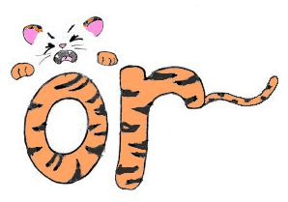
or
pork | sort
norm | port
shorts | cord
storm | for
horse | effort
fork | sword

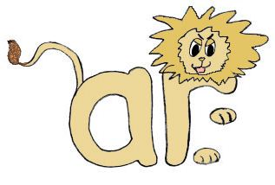
ar

far | bar
star | card
car | party
part | hard
park | mark
art | army

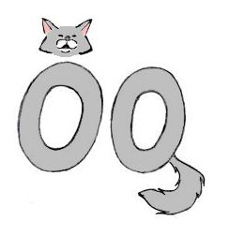

oo

good | stood
cook | took
foot | wool
look | book
tooth | wood

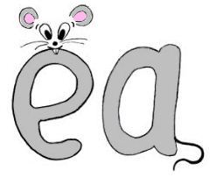
ea

see | tree
weak | need
deal | steal
sea | lead


ow
ou
now | noun
town | found
down | house
cow  brown | mouse  out

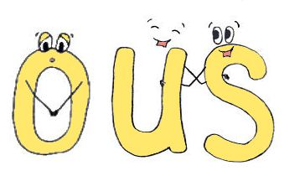
famous
dangerous
various
delicious
generous
curious
serious
ous


wh
what | where
whist | why
whale | white
when | wheel
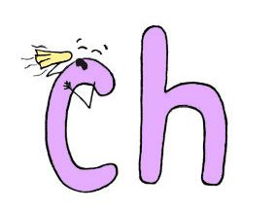
ch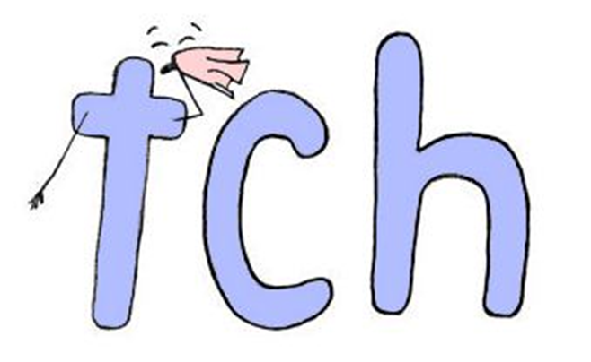

chin | rich
chill | catch
chat | chase
match | bench
champ | chest
chop | chess

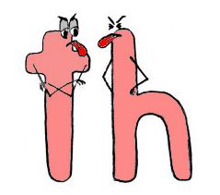
th

this | thick
they | both
the | month
that | thin
father | path
mother | mouth

